**CRACK THE COVID-19 CRISIS**

**BY**

[**NASSCOM FUTURESKILLS AND IBM**](https://beatest.in/challenge/3)

**Team Name:** SEVAK

**Title of the project:** Nirdeshi

**SOLUTION ARCHITECTURE**

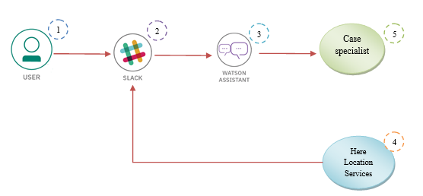

**Team Members:**

1. A.Shanmukha sai
2. J.Barath Raj
3. T.Dileep Goud
4. G.Sirisha

**Team Mentor: Dr.CH**. Santhan Kumar